Ignasi Arranz, Bertrand Fournier, Nigel P. Lester, Brian J. Shuter, and Pedro R. Peres-Neto. Species compositions mediate biomass conservation: the case of lake fish communities. Ecology.

Appendix S14. Environmental similarity of lakes over the latitudinal gradient

For each lake, we calculated the weighted mean environmental Euclidean distance between that lake and all other lakes. All environmental factors were standardized to zero mean and unit variance prior to calculating pairwise environmental distances between lakes. Weighting was based on the geographical distance between lakes. As such, smaller means indicate lakes are environmentally more similar to lakes in their geographic vicinity. Areas with smaller environmental distances represent more environmentally stable areas (i.e., the environment is similar across lakes).

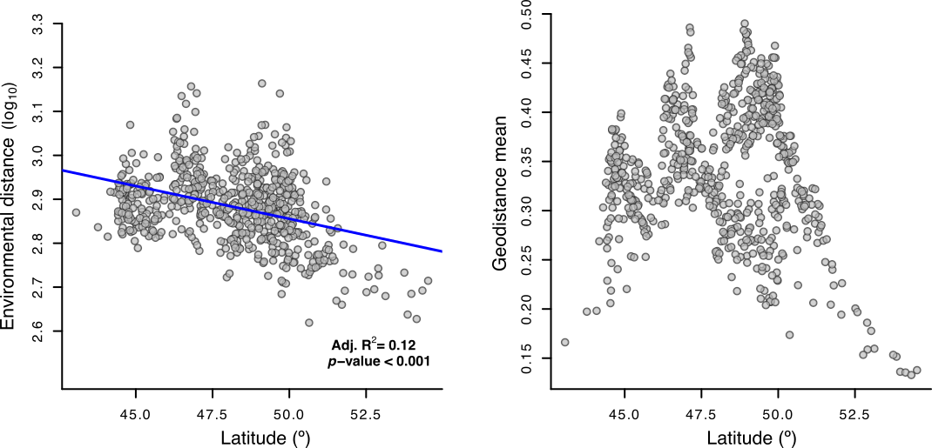

**Figure S1.** Plots showing (a) latitudinal variation (*x-*axis) in the weighted mean environmental distance (*y-*axis) and (b) latitudinal variation (*x-*axis) in the mean geographic distance of each lake (*y-*axis). Panel (a) indicates that northern lakes (i.e., higher latitude) are more environmentally stable than southern lakes. Panel (b) indicates that lakes at intermediate latitudes tend to be further from each other. Although variation in panel (a) does reflect some of the latitudinal dependence evident in panel (b), the overall trend of decreasing environmental distance with latitude is not present in panel (b) and hence we can conclude that the physical proximity of lakes is not responsible for the latitudinal trend in environmental stability evident in panel (a).